Run the collection remotely using collection URL:-

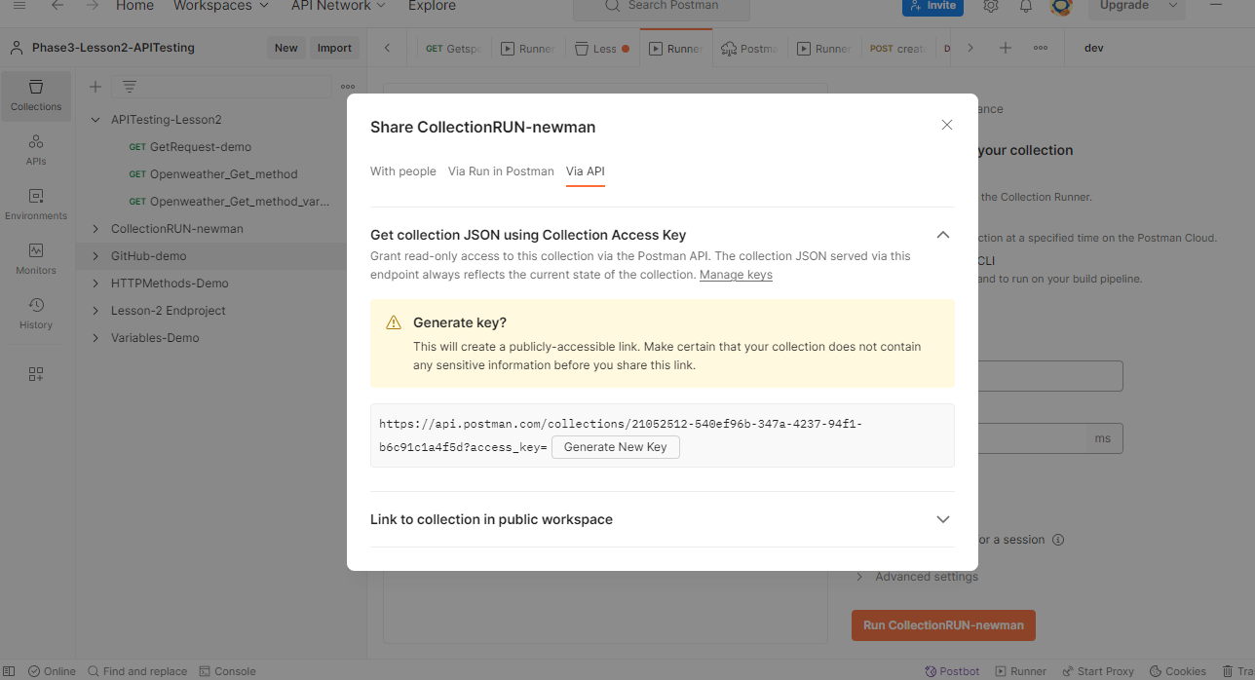

Click on Generate new key and copy the URL



copy the URL:-

https://api.postman.com/collections/21052512-540ef96b-347a-4237-94f1-b6c91c1a4f5d?access_key=PMAT-01HEMJMKTTHSHNNNG7QH2BAPWJ

Now go to cmd prompt of windows and execute the newman command

# newman run <Copied URL>

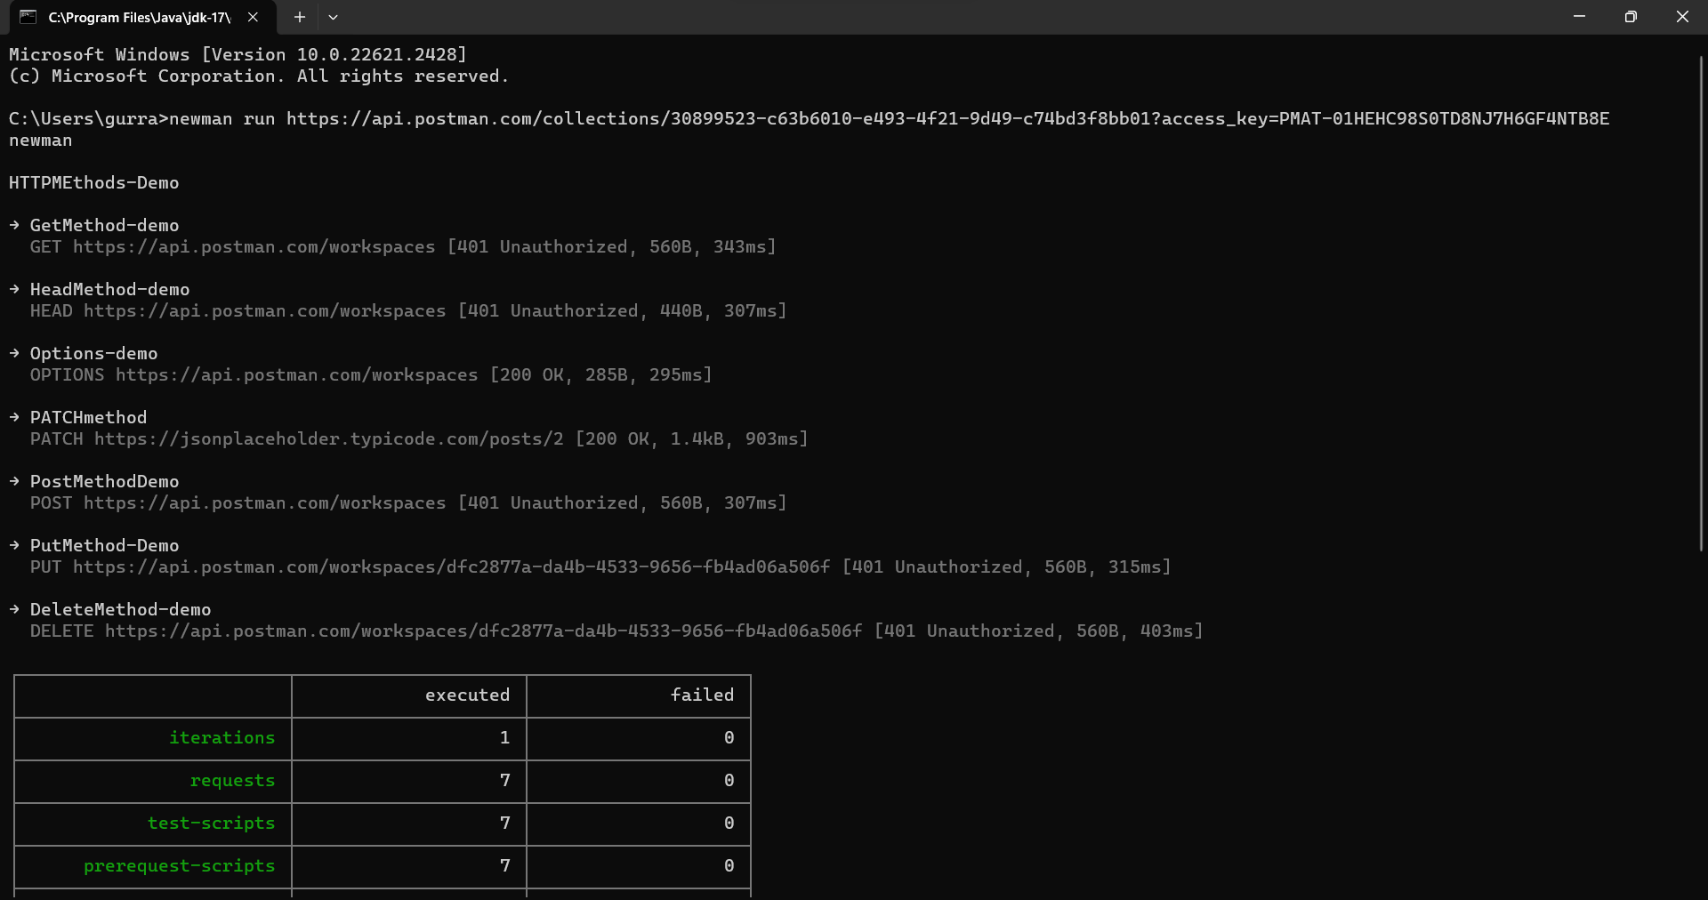

It will run the collection successfully.

Run collection with Jenkins using postman CLI

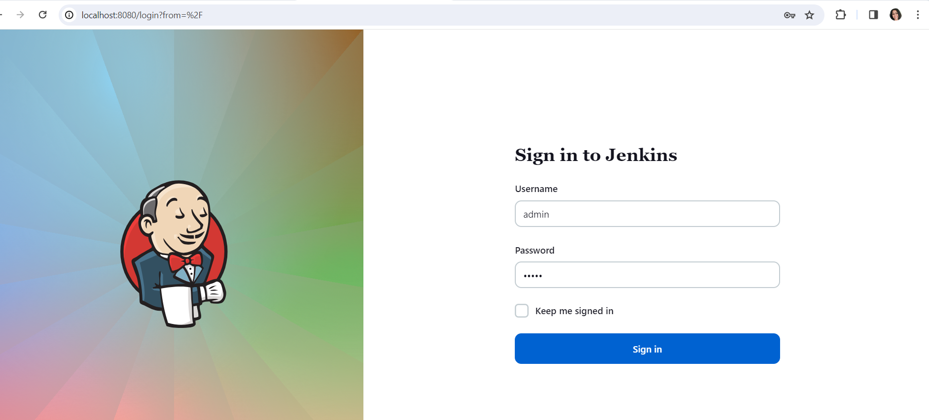

Download nodejs plugin in Jenkins

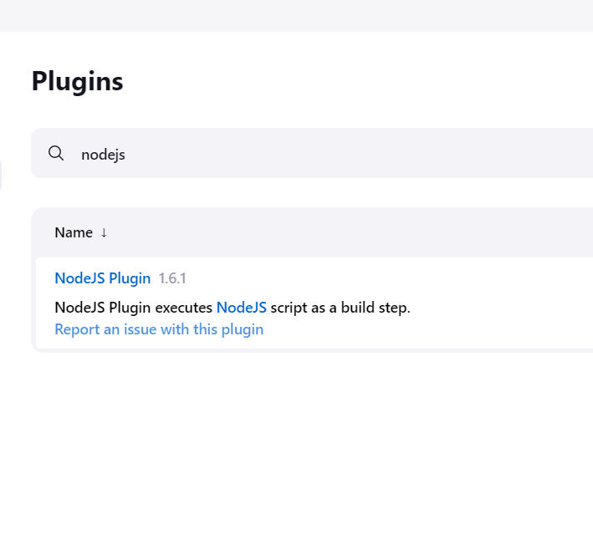

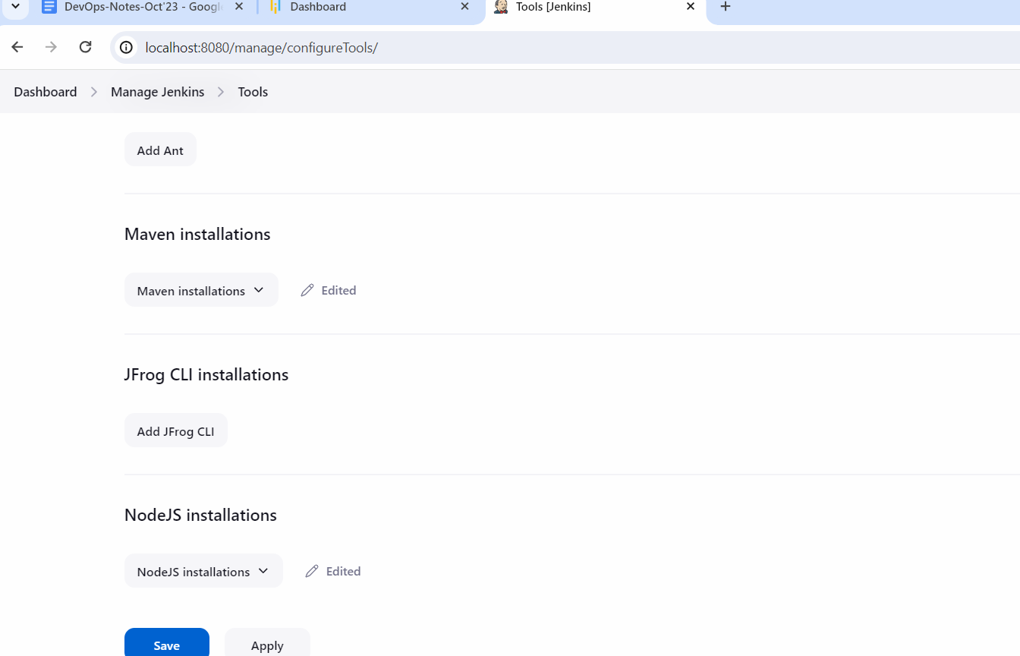

Now go to collection runner

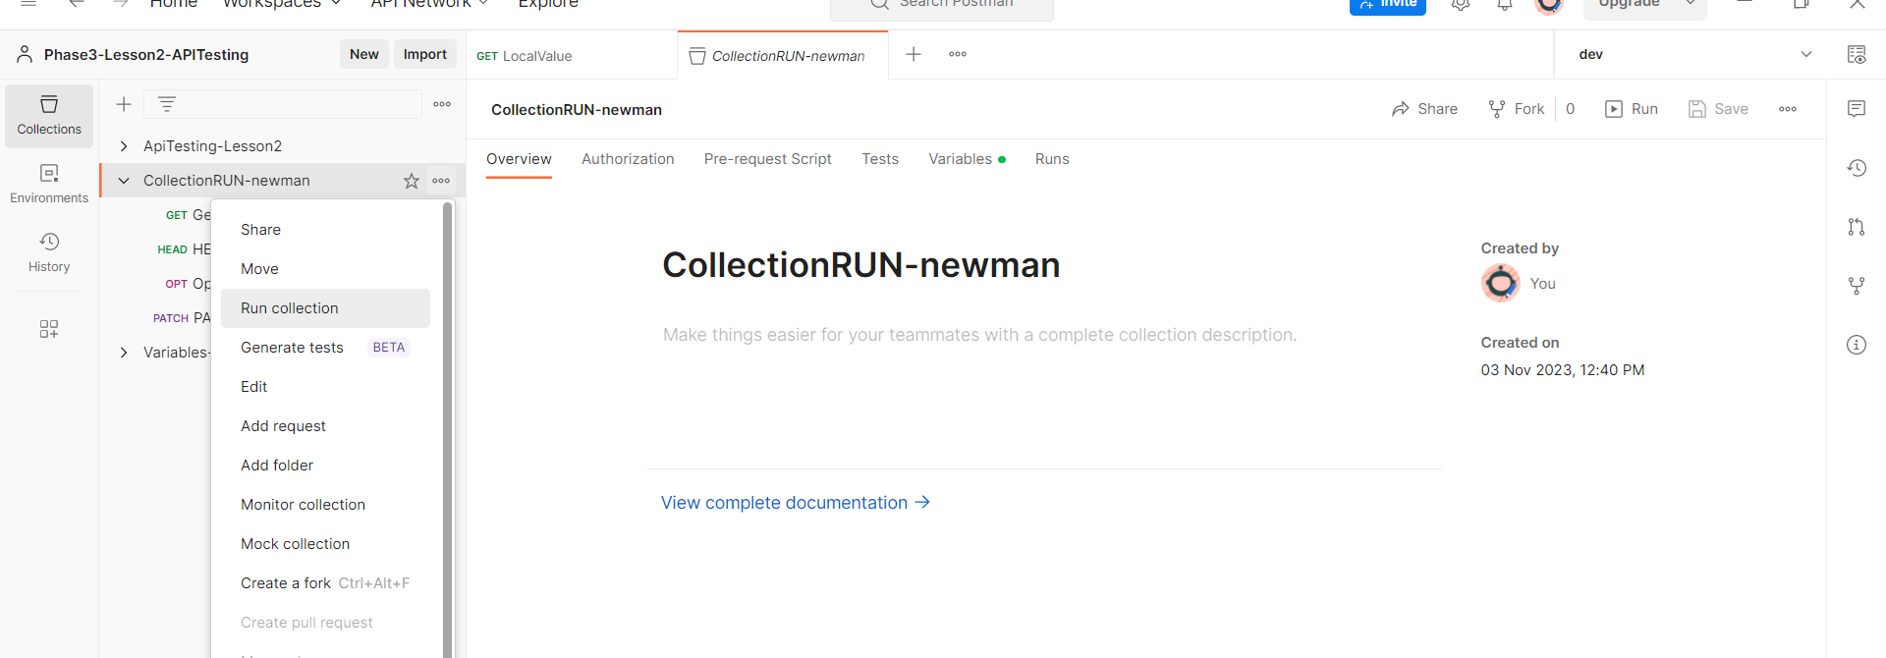

Click on configure command

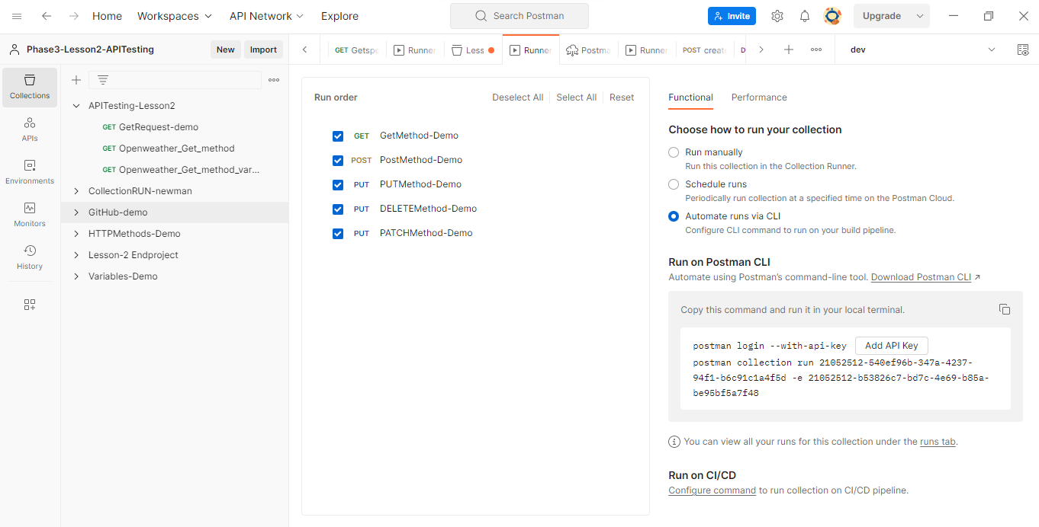

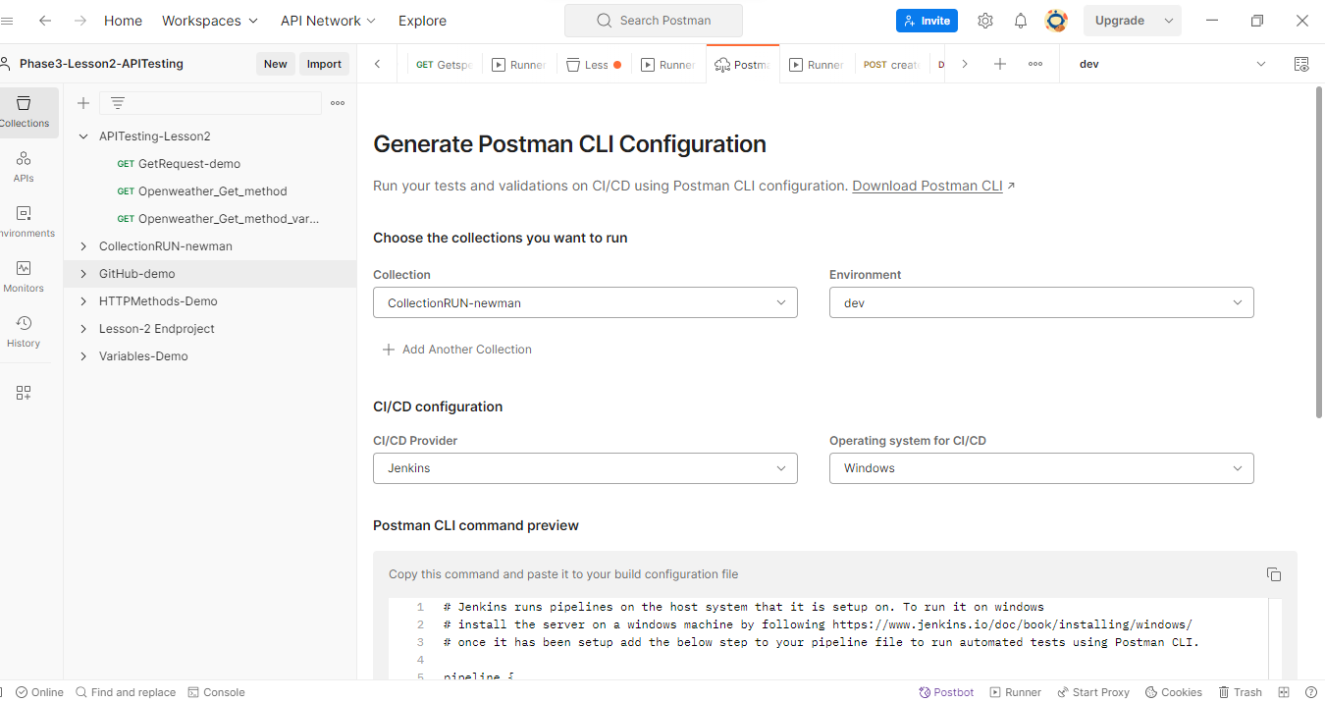

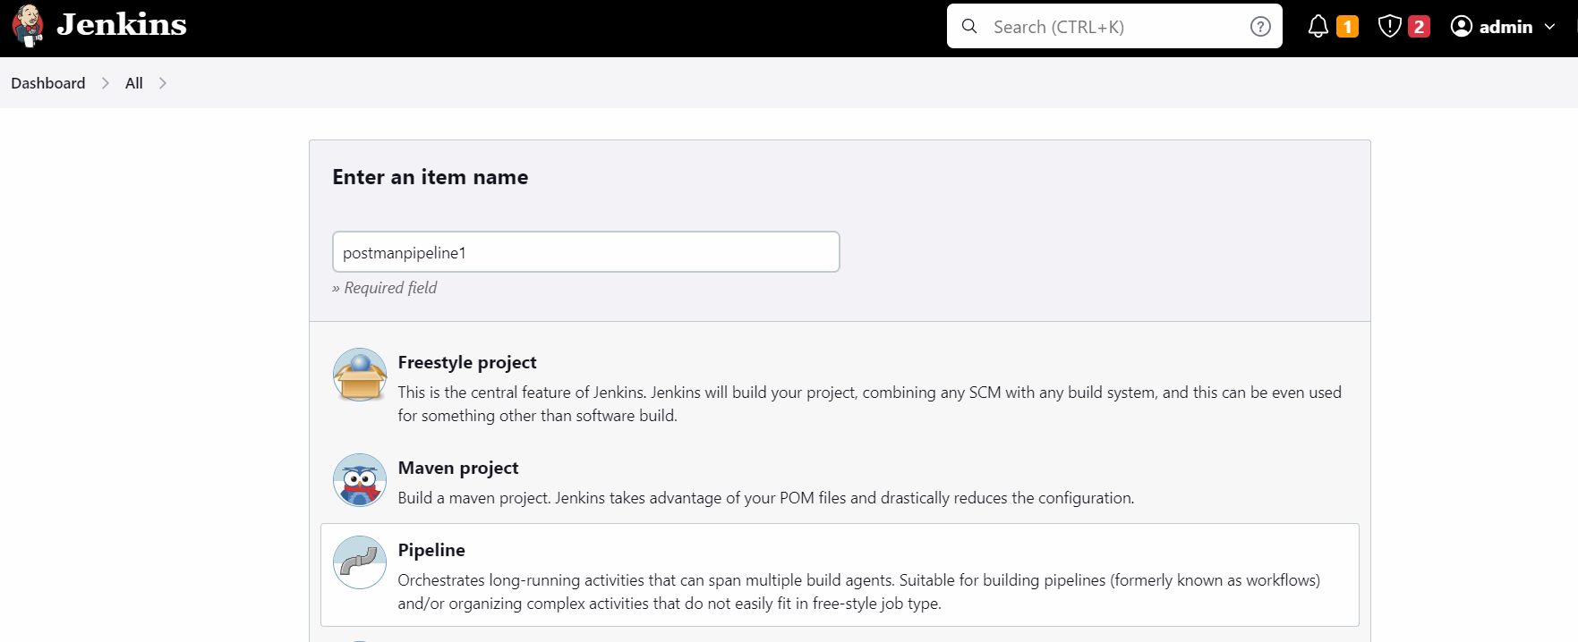

Now copy the entire script form postman

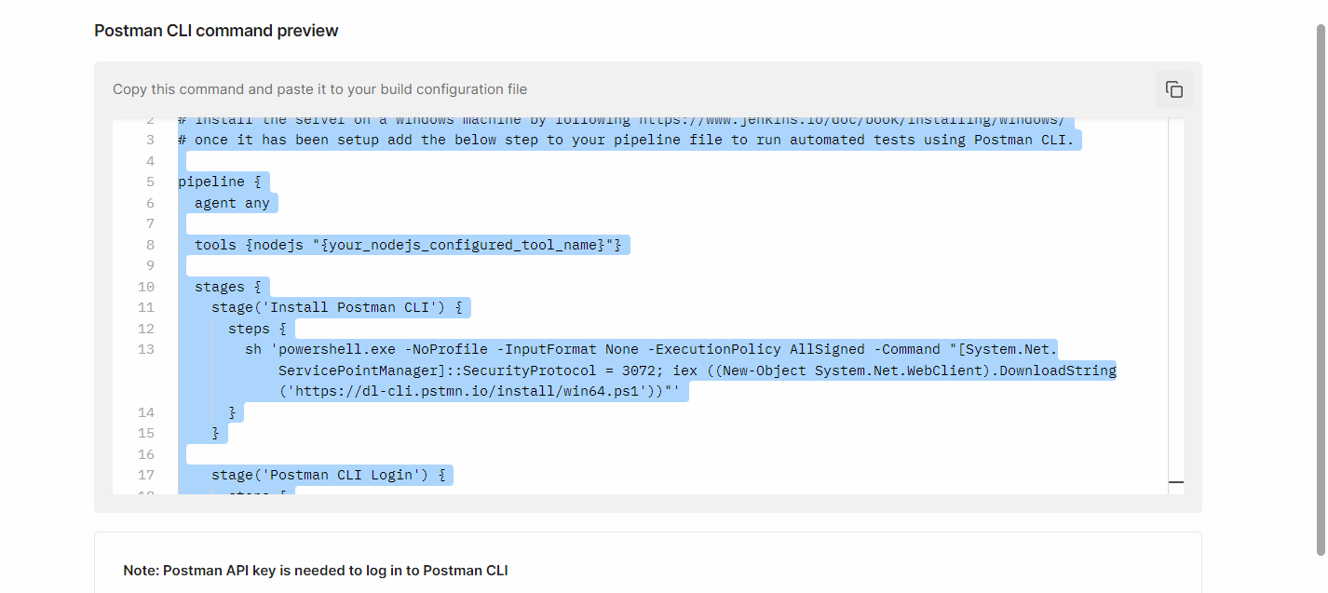

Copy this pipeline in Jenkins Job

Here select windows batch script

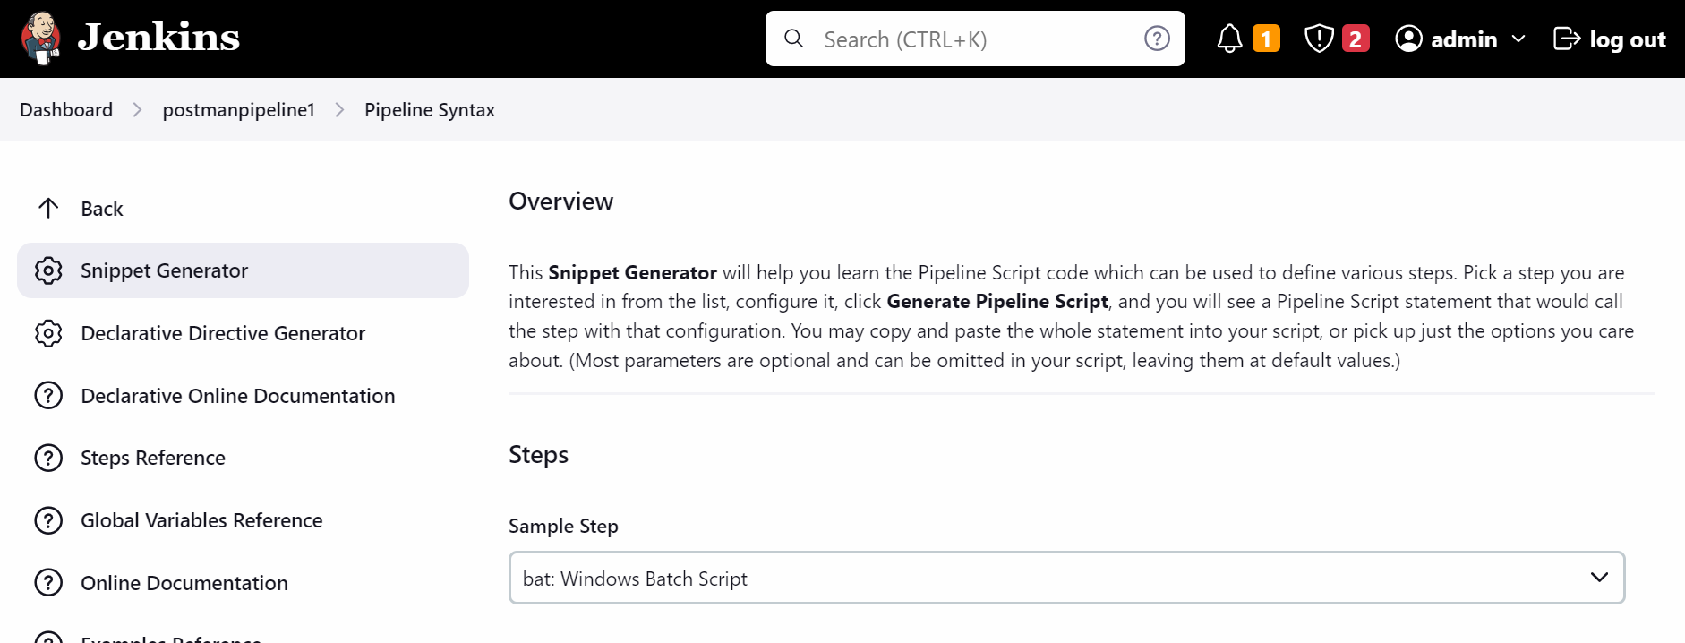

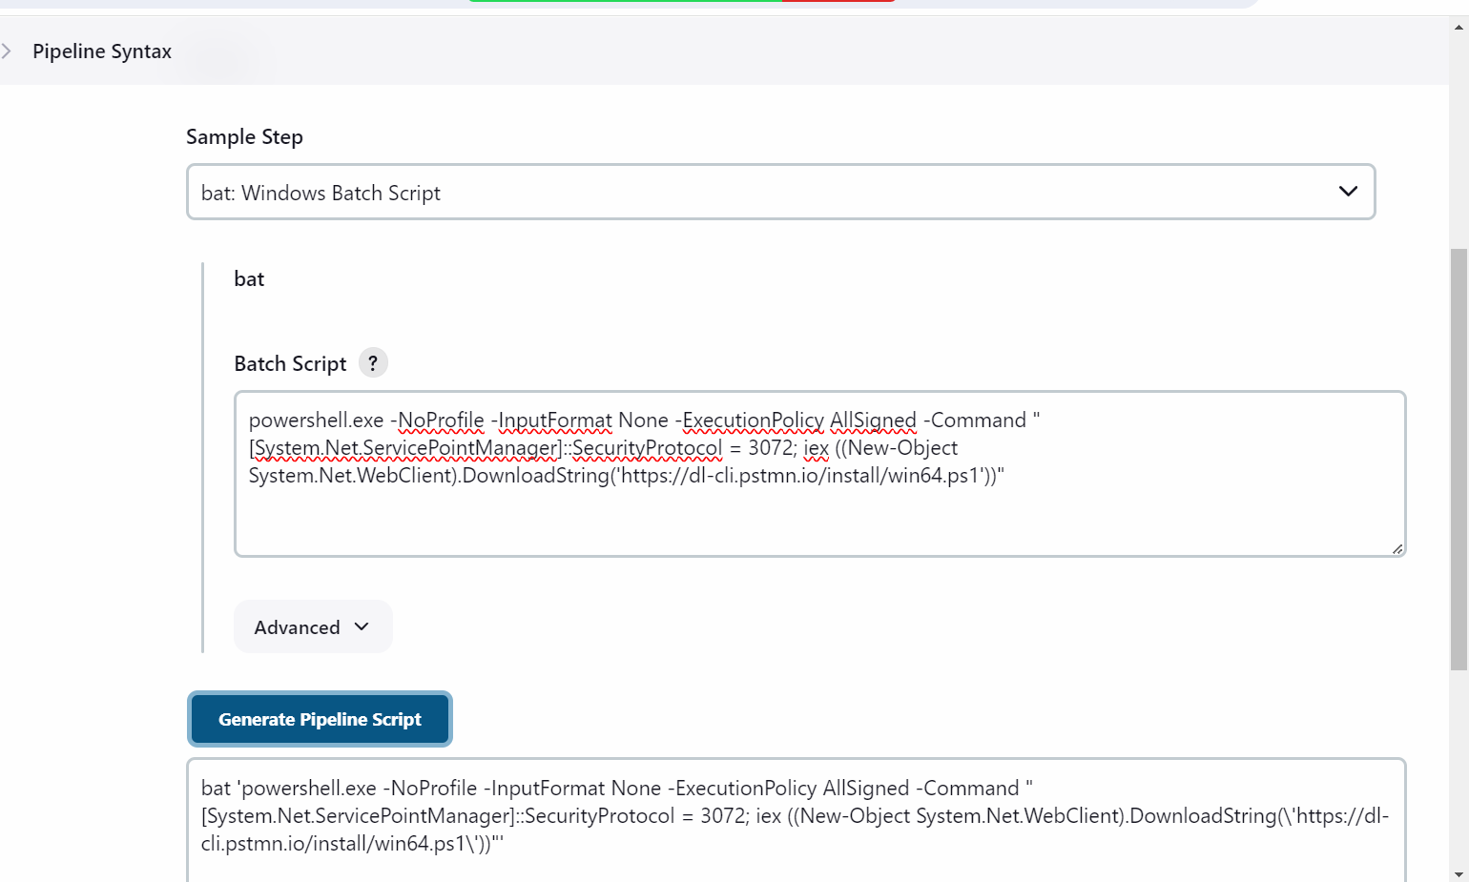

Now go to jenkisn job.. remove the sh command in first stage and add the bat command

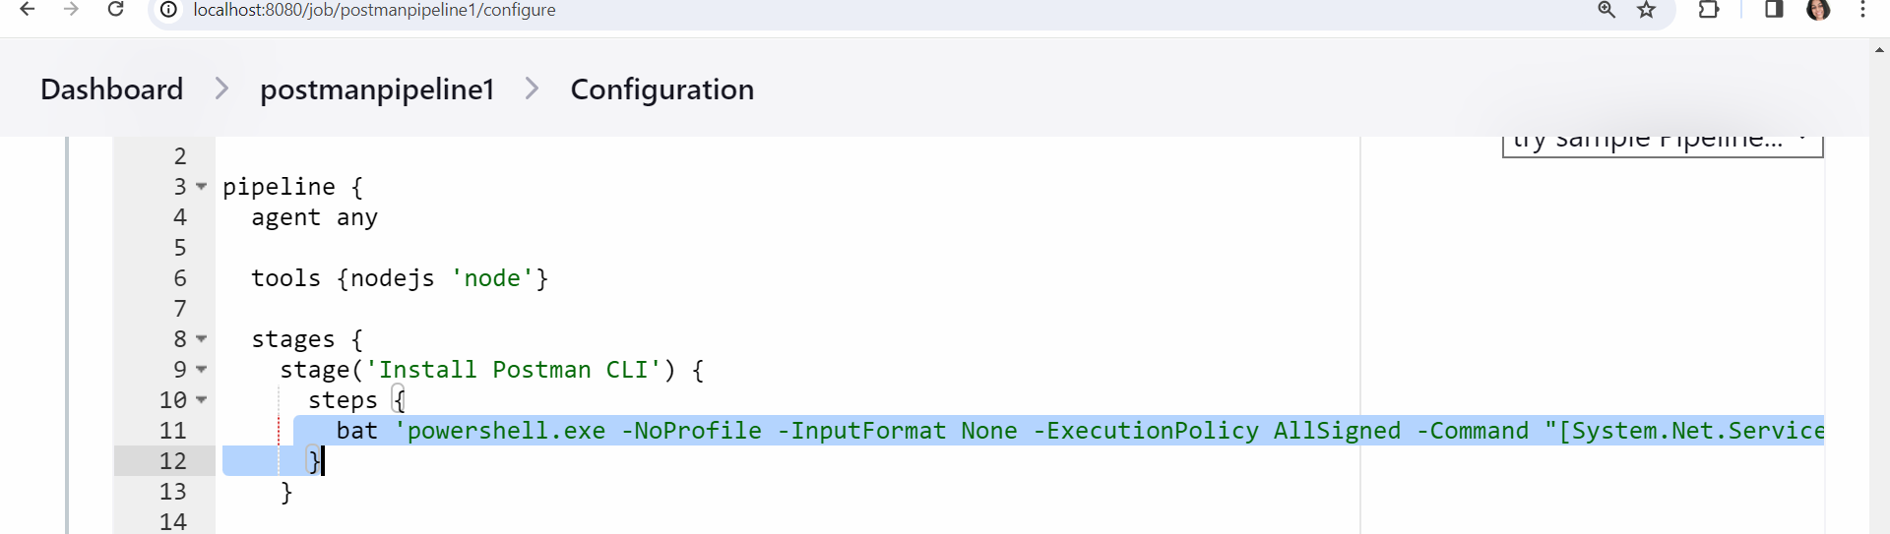

Get the api key from postman

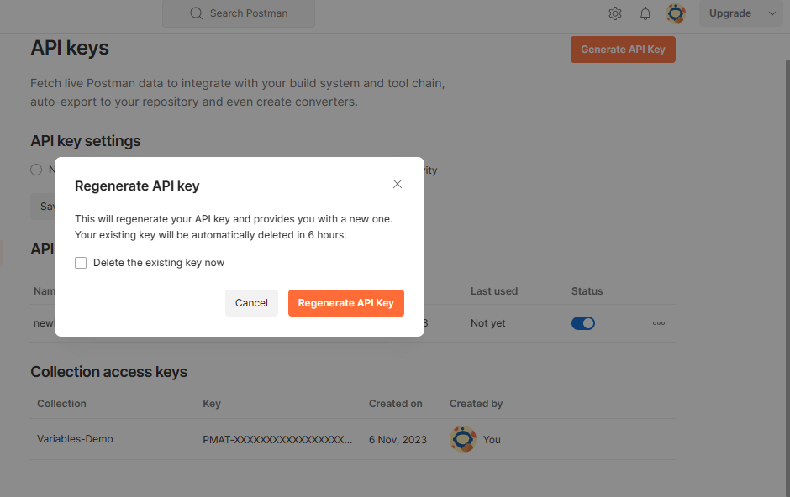

Click on regenerate APIkey

Go to Jenkins pipeline code

Stage 2 -> change sh to bat

And replace $POSTMAN_API_KEY to the actual postman apikey value

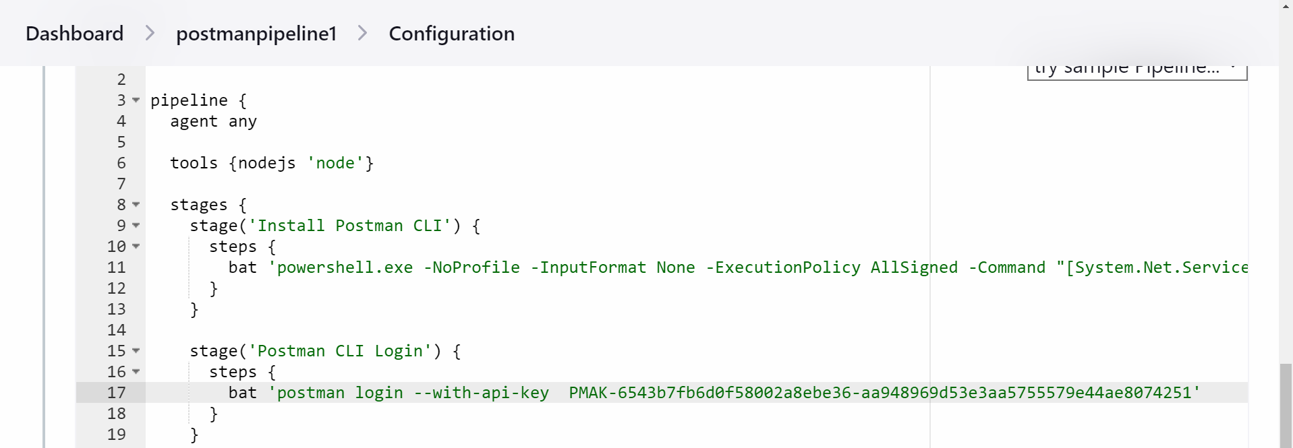

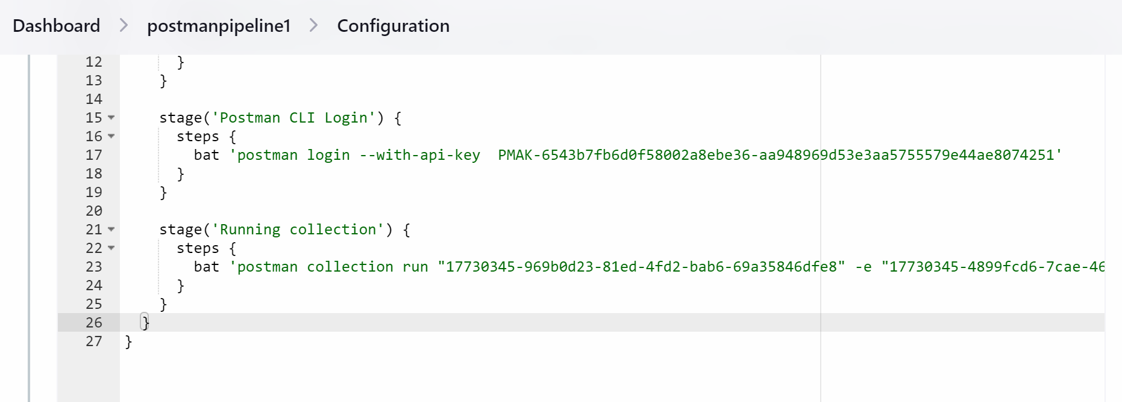

Monitors:-

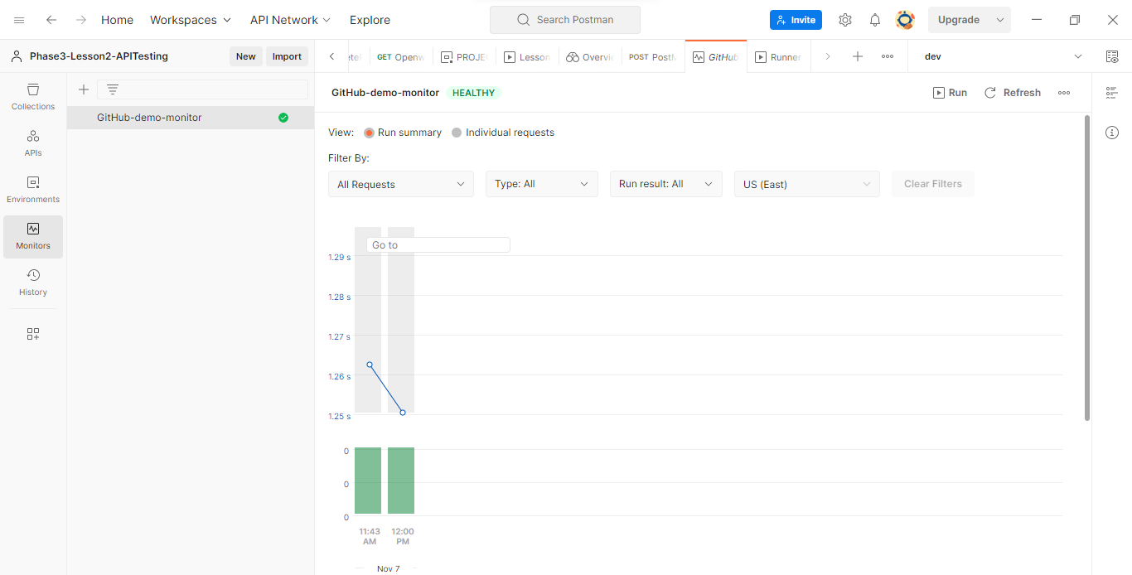

GitHub API:-

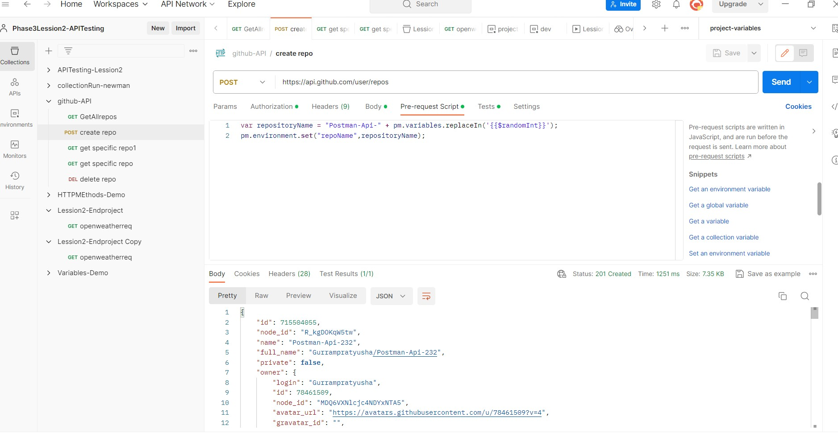

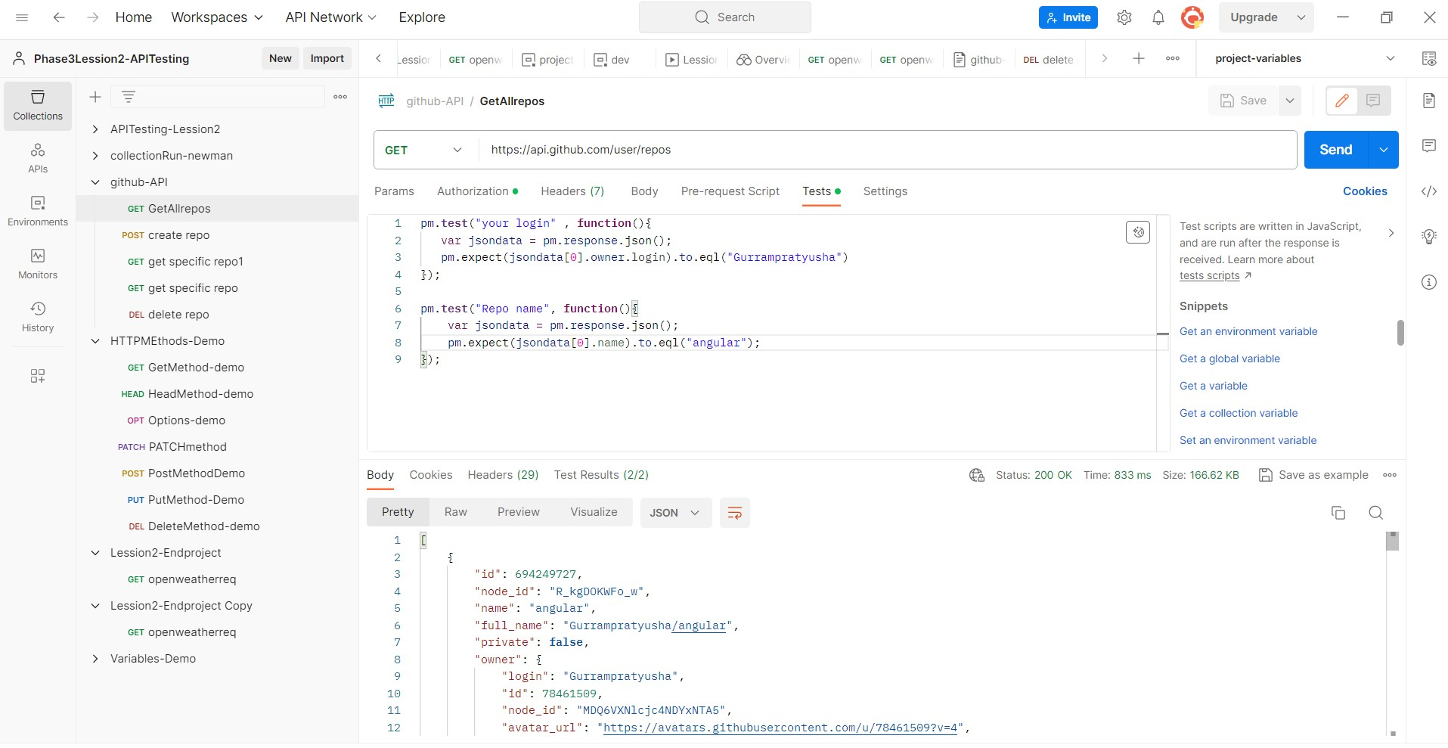

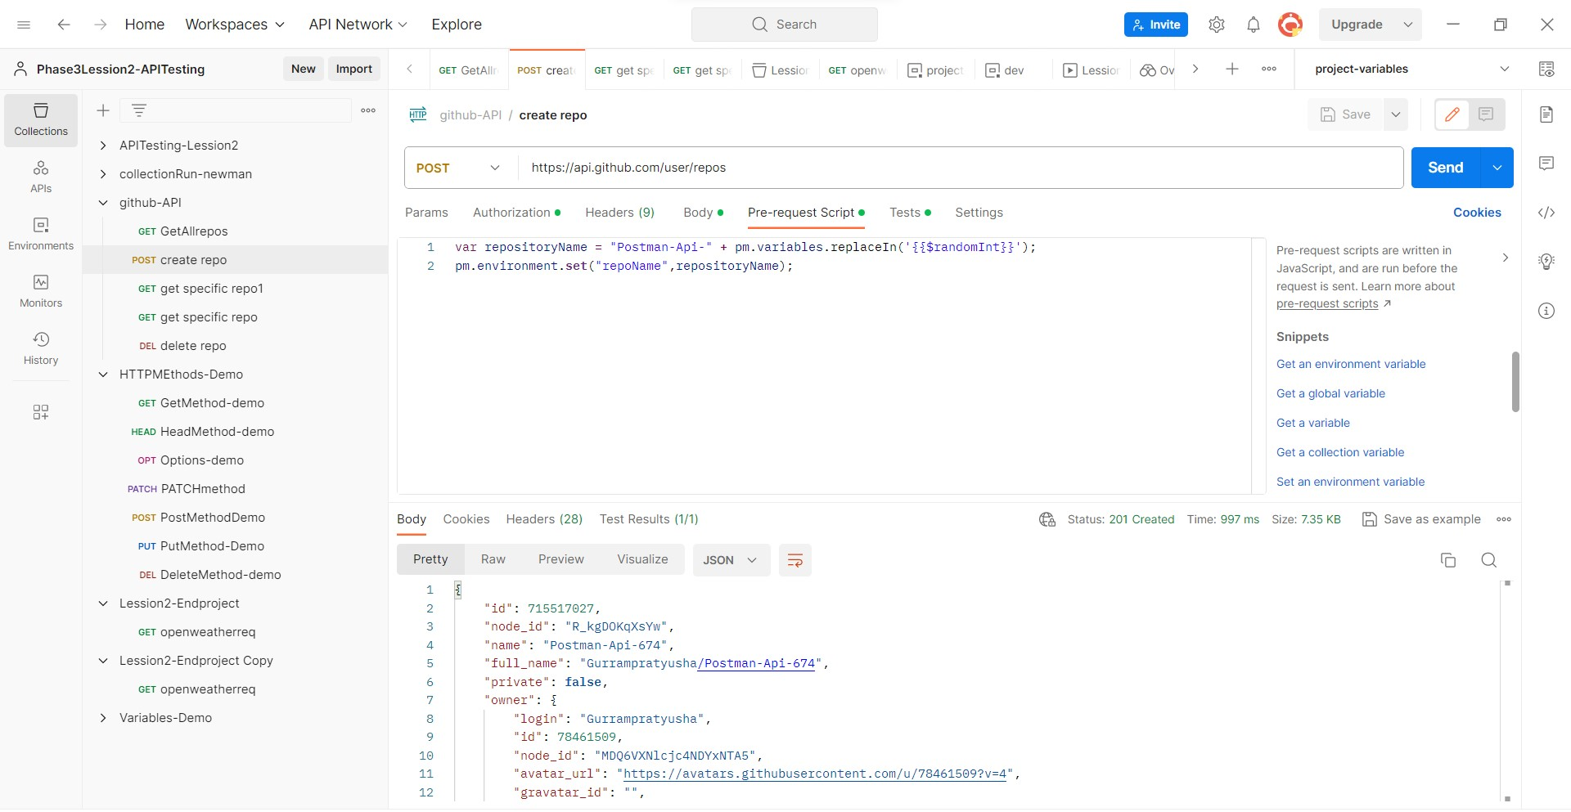

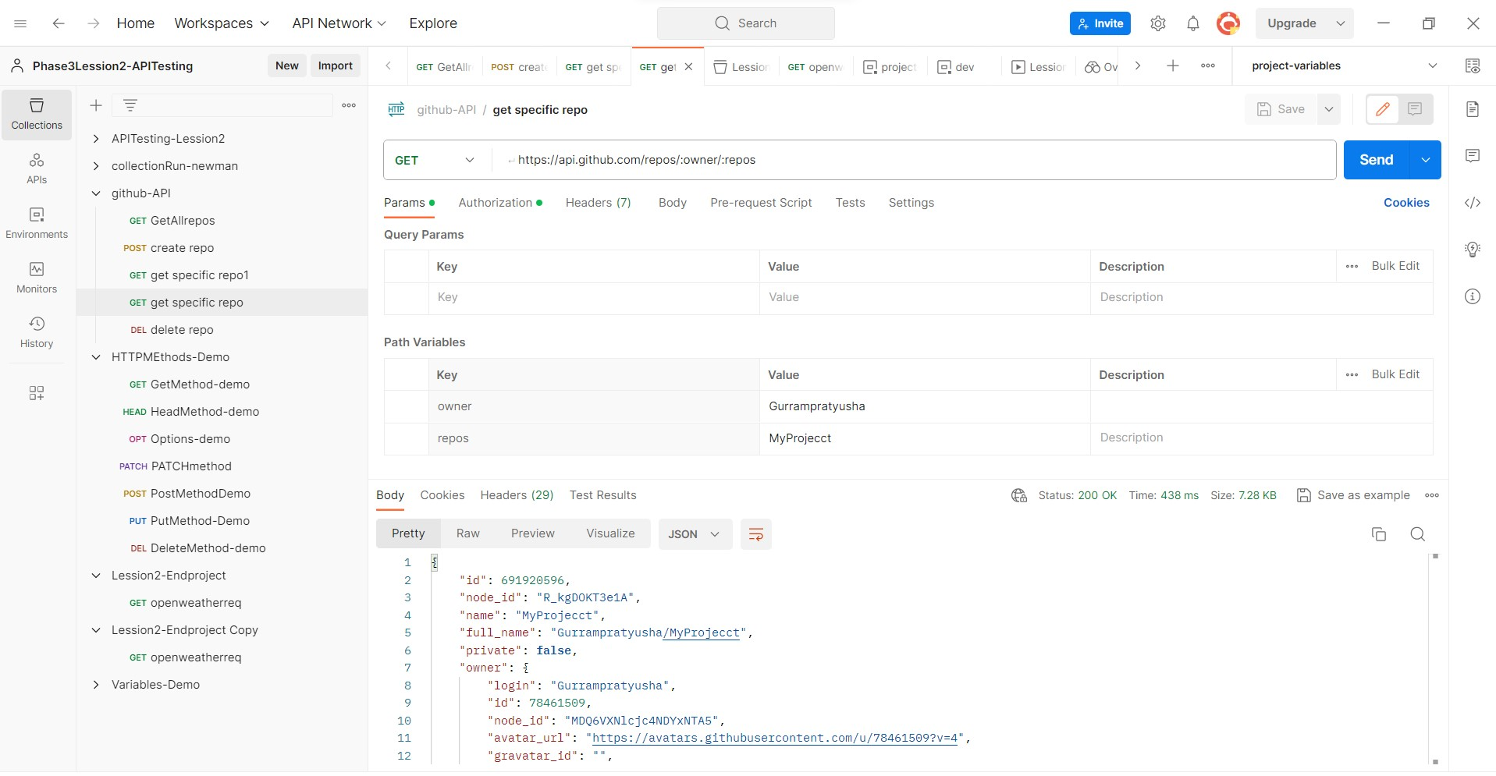

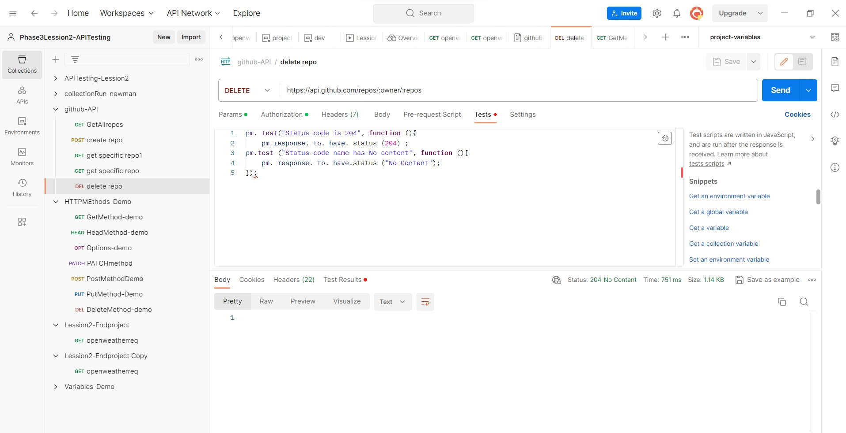

API Documentaion:-

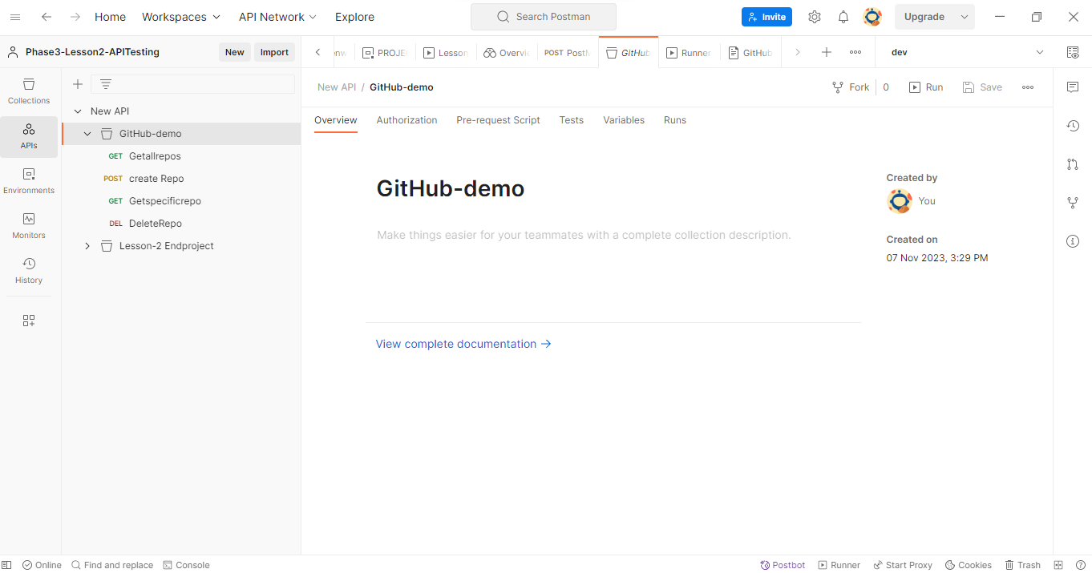

Click on view complete documentation

